Lesson 9 : Area and volume (C)

Checkpoint 1


1. The figure shows a scale drawing of a fish. Its scale is 1 : 4. If the length of the fish in the drawing is 5 cm, find the actual length of the fish in cm.

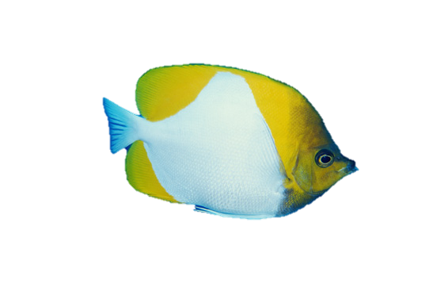
5 cm

2. Victor wants to make a scale drawing of a building with a scale of 1 cm : 9 m. If the actual height of the building is 126 m, what should be its height in the drawing in cm?

3. The figure shows the floor plan of a rectangular room with a scale of 1 : 400. The length and the width of the room on the plan are 4.5 cm and 3.5 cm respectively. Find the actual area of the room in m².

Checkpoint 2

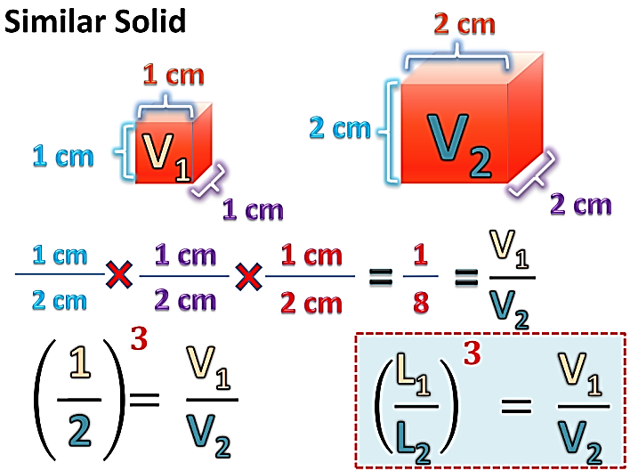

Volume Ratio
Area Ratio

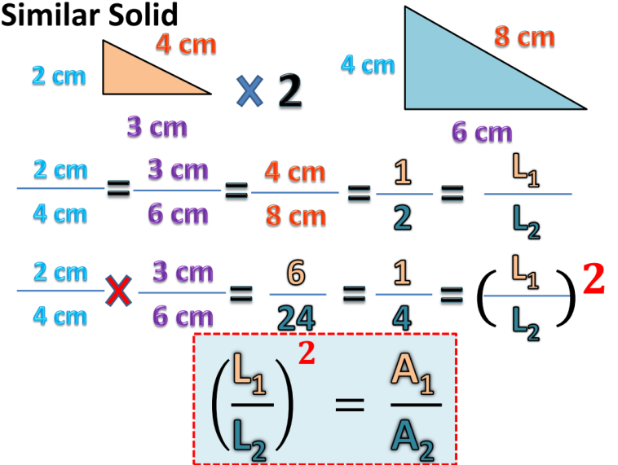
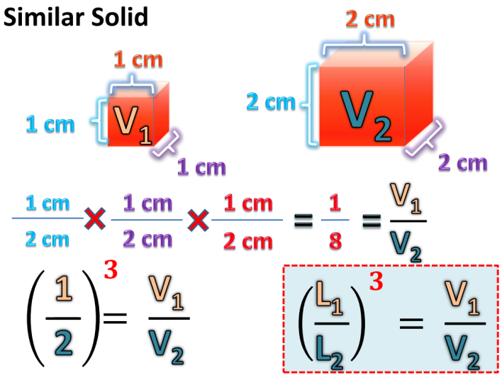

4. Find the unknown in each of the following pairs of similar plane figures, where the marked lengths are corresponding lengths.
(a)

(b)

(c)

area = 2.7 cm²

5 cm

3 cm

area = T cm²

area = P m²

area = 324 m²

28 m

36 m

32 cm

area = 16 cm²

area = 9 cm²

x cm

5. Find the unknown in each of the following pairs of similar solids, where the marked lengths are corresponding lengths.
(a)

(b)

(c)

(d)

4 cm
total surface area = 200 cm²
total surface area = x cm²
3 cm

15 m
9 m
volume = 24 000 m³
volume = v m³

h cm
3 cm
total surface area = 36 cm²
total surface area = 81 cm²

x mm
1 mm
volume = 125 mm³
volume = 64 mm³

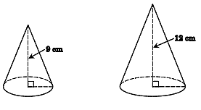

6. The heights of two similar right circular cones are 9 cm and 12 cm respectively. Find the ratio of
(a) the total surface area of the large cone to that of the small cone,
(b) the volume of the large cone to that of the small cone.

7. The volume of water that a right conical vessel can hold is 480 cm³. If it is filled with water up to half of its depth, find the volume of water in the vessel.

8. Find the volume of the frustum of a right circular cone in the figure in terms of π.

45 m
20 m
8 m
18 m

9. In the figure, BCED is a frustum of a right circular cone. Find the curved surface area of the frustum in terms of π.

10 cm
C
B
E
D
P
Q
15 cm
40 cm
A

10. In the figure, the upper base and the lower base of the frustum of a right pyramid are squares. Find
(a) the total surface area of the frustum,
(b) the volume of the frustum.

48 cm
15 cm
30 cm
17 cm
34 cm
32 cm

11. The figure shows a frustum of an inverted right circular cone. The radii of its upper base and lower base are 14 cm and 10.5 cm respectively. Find
(a) the length of AP,
(b) the volume of the frustum in terms of π.
(c) the total surface area of the frustum in terms of π.

48 cm
A
C
B
E
D
P
Q
14 cm
10.5 cm

12. The figure shows a frustum BCDEFGHI of a right pyramid. Its upper base and lower base are rectangles. The height of the frustum is 9 cm. Let h cm be the height of the pyramid AFGHI.
(a) Find the value of h.
(b) Find the volume of the frustum.

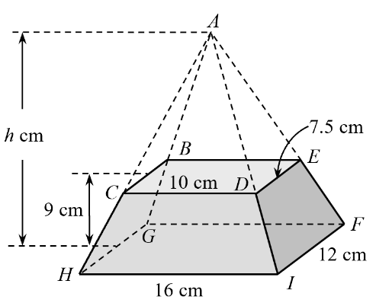

13. A paper cup is in the shape of an inverted right circular cone of base diameter 6 cm and height 12 cm. Suppose the cup is held vertically and it is originally filled up with water. If some water flows out of the cup until the depth of water drops 6 cm as shown in the figure, find the volume of the water flowing out in terms of π.

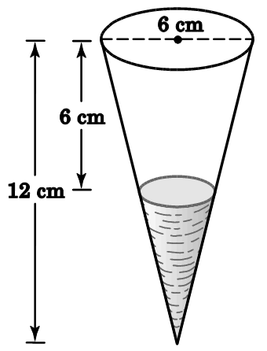

14. The figure shows a vessel of capacity 324 cm³. Its shape is an inverted right pyramid whose base is a horizontal square XYTU of side 9 cm. The vessel contains water to the depth of 8 cm.
(a) Find the height of the vessel.
(b) Find the additional volume of water required to fill up the vessel.

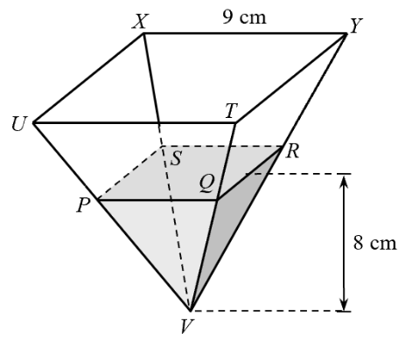

15. In the figure, a right circular cone P is divided into a frustum X and a right circular cone Y. The cones P and Y are similar. The heights of X and Y are 6 cm and 24 cm respectively.
(a) Find the volume of the frustum X : the volume of the cone Y.
(b) If the curved surface area of Y is 400 cm², find the curved surface area of X.

6 cm
P
24 cm
X
Y

16. The figure shows a right rectangular pyramid VTUXY. It is cut by a plane parallel to its base into pyramid VPQRS and frustum PQRSTUXY. It is given that area of △VPS : area of quadrilateral PSTU = 4 : 5.
If the volume of pyramid VTUXY is 1 080 cm³, find the volume of frustum PQRSTUXY.

U
V
T
X
Y
P
S
Q
R

17. David has a cup containing some water. The shape of the cup is a frustum of a right circular cone standing vertically as shown in the figure. The circumferences of the upper base and lower base of the cup are 20 cm and 12 cm respectively. The ratio of the curved surface area of the cup to that in contact with water is 256 : 81.
(a) Find the circumference of the water surface.
(b) David claims that the ratio of the capacity of the cup to the volume of water is ${\left(\frac{\text{16}}{\text{9}}\right)}^{\text{3}}$. Do you agree? Explain your answer.

